**Grade 12 Computer Engineering**

**Vex Challenge**

**Technical Report**

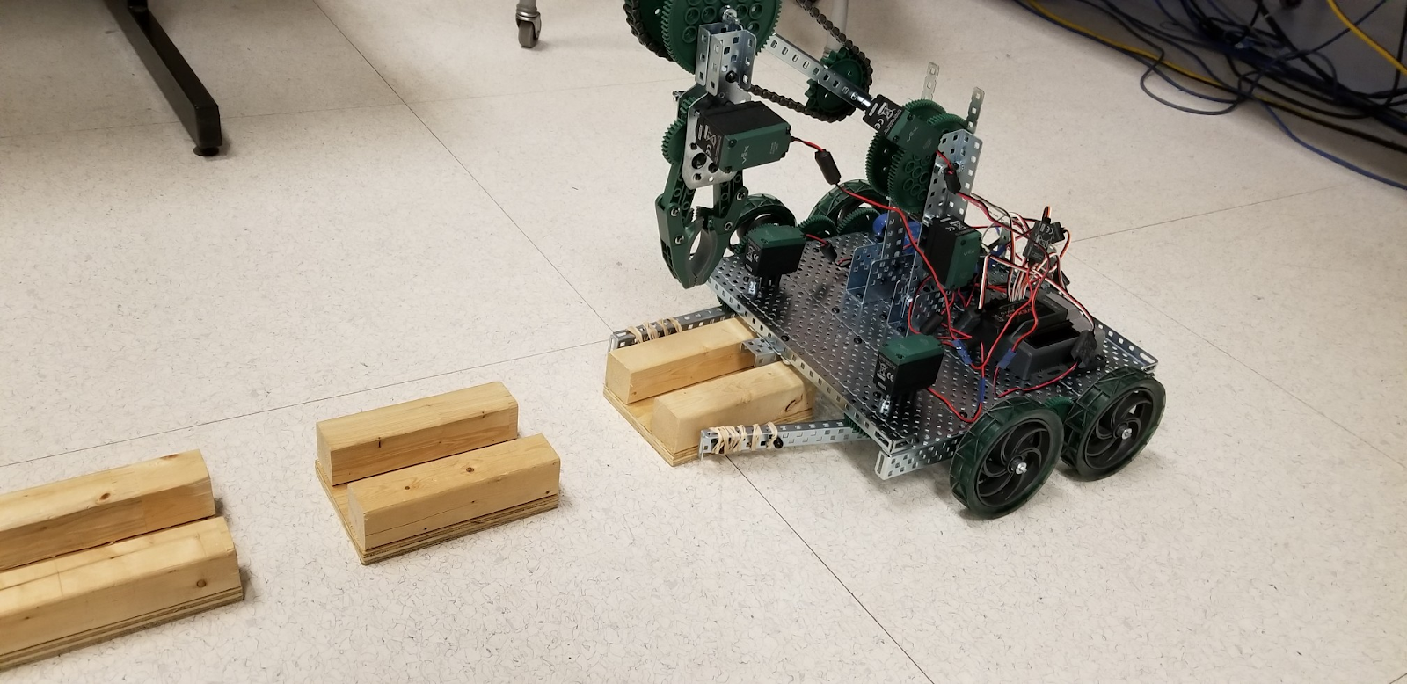

January 21, 2019

TEJ 4MR

Mr. Edgar

Asad Bhatti

566609

|  |
| --- |
| **Table of Contents:** |

**Problem Description Pg.2**

Situation ...………………………………………………………………………. Pg.2

Problem and Possibilities ……………………………………………………… Pg.4

Investigation and Ideas ………………………………………………………… Pg.5

Choose and Construct …………………………………………………………. Pg.7

Evaluate ………………………………………………………………………….. Pg.12

**Overview of Solution Pg.13**

Materials …………………………………………………………………………. Pg.15

**CAD Drawings/Sketches/Codes Pg.20**

CAD Drawings …………………………………………………………………… Pg.20

Sketches ………………………………………………………………………….. Pg.20

Codes ……………………………………………………………………………... Pg.21

**Daily Journal Pg.27**

**Self-Evaluation Pg.30**

**References Pg.32**

**Problem Description:**

**Situation:**

An oil company would like to allow their oil to become more accessible by creating pipelines that extend as far as possible and is looking for a robot that would be able to create this pipeline. Not to mention, they prefer to have a robot that is capable of automatically suppling pipes to the pipeline construction zone.

In order to get the company to favour your robot, the competitors must learn and apply the following skills:

* Drafting (Create sketches and brainstorm possible robot designs)
* Mechanics (Control the robot effectively and complete required task with in time limit)
* Electronics (Wire all electronic components neatly and properly)
* Computer Programming (Program robot such that it is capable of completing the tasks given)
* Metalwork (Through use of metal materials create a sturdy and effective machine to complete challenge)
* Communications (Communicate with team members throughout competition to create the best robot possible)

The purpose of this challenge would be to create an engineering project to push the limits of individuals with different skill sets to form teams consisting of two-three members to design, create, code and operate a robot with the intent that students are independently designing, and manufacture/operating robots capable of completing the competition tasks in competition with other student-manufactured robots. As such, they should be able to have their robot favoured by the oil company.

The company will provide a test ground as well as 9 wooden cradles, 9 pipes and 3 pipe stands. While the competitors must complete the challenges within 3 minutes.

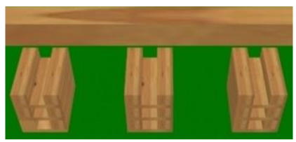 Pipe Cradles One possibility of stacking the pipes

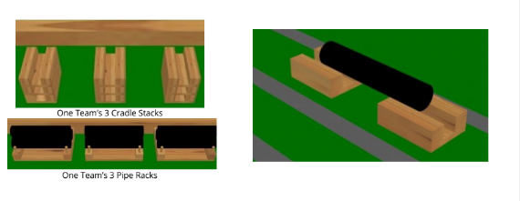

Pipes as well as Pipe stands 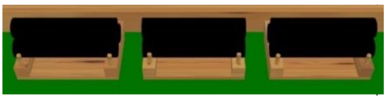

Test grounds:

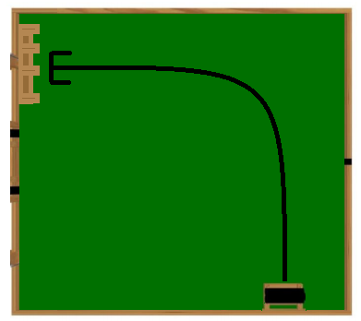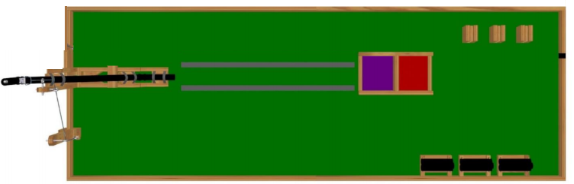 Manual Robot Control Competition Autonomous Competition:

Scoring:

Points will be awarded as follows:

* 1 point for each pipe cradle placed between the tape lines
* 2 points for each pipe placed on a cradle
* 3 points for each ball that passes through the completed pipeline

With a total of 5 balls of oil a team can score up to 54 points.

**Problem and Possibilities:**

The robot must be able to supply pipes automatically to the pipeline construction zone and be able to build a long and sturdy pipeline that is capable of transporting balls of “oil” away from the station. The robot must create a straight pipeline composed of at least 3 pipes connected to the main station allowing the oil balls to pass through all three pipes. To prevent the pipes from falling or rolling over when the oil is transported the pipes must be elevated by sturdy wooden blocks (pipe cradles).

The robot could contain a block collector system to allow the robot to grab and place as many wooden blocks as possible. It could also contain a rotational claw to allow the robot to grab pipes regardless of position allowing for ease of access. Finally, it should contain some sensors to allow the robotic unit to navigate the field and be able to perform its job effectively.

**Investigation and Ideas:**

Appropriateness of size:

* Would need to be as compact as possible to allow for ease of access in tight spots
* Would need to be big enough to be capable of collecting and storing wooden blocks underneath robot

Appearance and Performance:

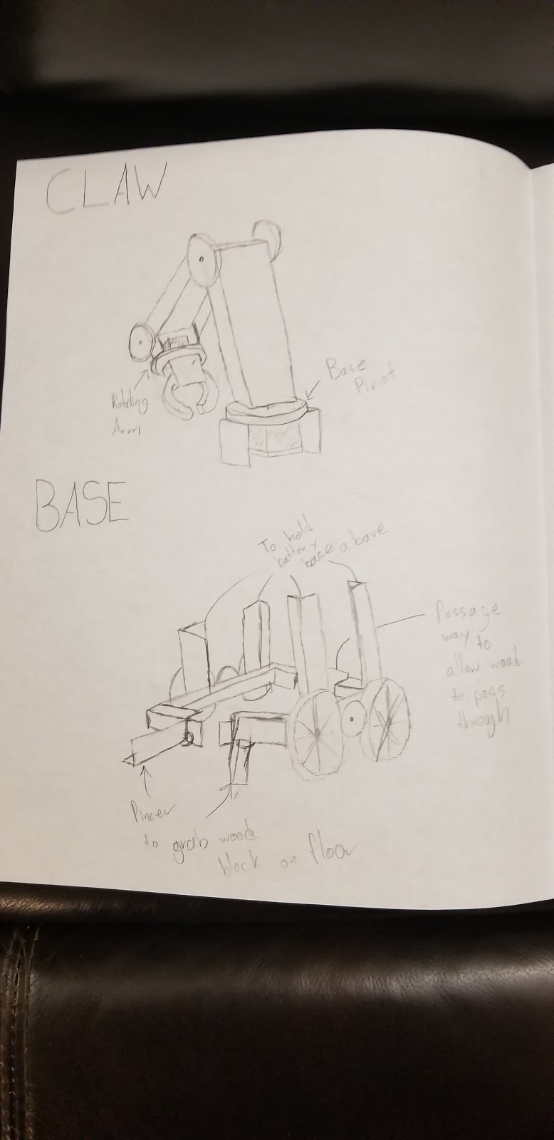 The bottom floor would have two responsibilities, it would be the unit’s chassis and act as an intake system. This intake system would consist of pincers that would grab the wood blocks and then release them when they would be in the right position. After that the VEX unit would release the block and pass over it, using a gap on the opposite end of the bottom floor, creating a “drive through” system.

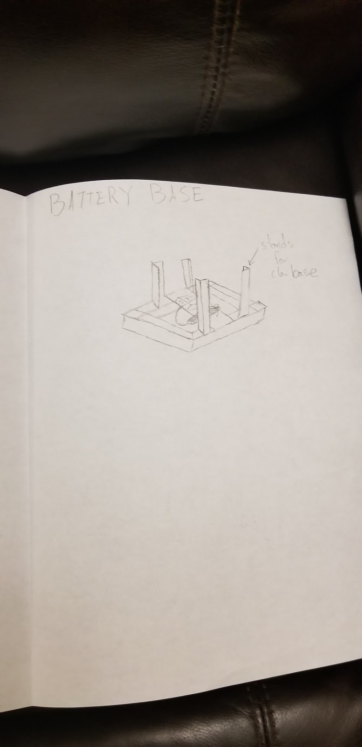 The middle floor would be the unit’s main control center, consisting of the VEX controller and a battery to power the entire machine. I had initially devised separating the controller and battery from the bottom floor as I thought they would prevent the wooden block from passing through the robot.

 The top floor would consist of the unit’s main arm. This arm would be versatile allowing it to easily grab pipes and blocks from an elevated platform and then be capable of placing an object from any angle at any height. As such, the arm would successfully complete the “drive through” system by simultaneously placing the pipe on the wooden block that would come out of the back of the robot.

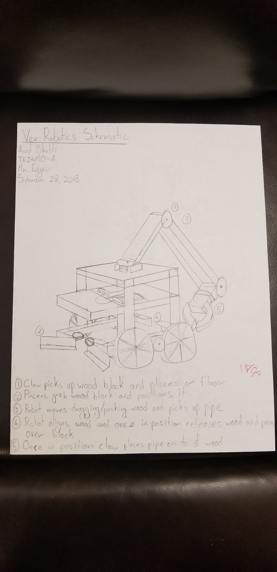

As such I intended to create a system that allowed my robot to effectively place a pipe cradle and a pipe at the same time. Thus, creating a maximum of 3 trips to complete the challenge.

**Choose and Construct:**

Step by step process:

1. When beginning this assignment, I had begun creating a basic chassis with the intention of building the robot around this specific chassis design. The chassis comprised of:
   1. 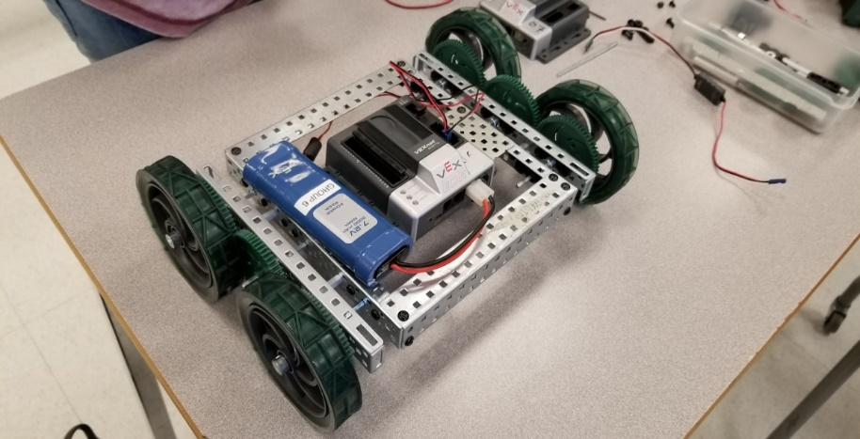A small metal frame - (Two 2x2x15 steel chassis bumpers, two 2x1x16 steel chassis rails, and one 5x15 steel plate)
   2. Two sets of wheels - One set containing (One 2x1x16 steel chassis rails, three medium sized gears, two rubber wheels, and three 3” metal shafts)
   3. A vex controller and battery
2. Once the basic chassis was completed, I began to run multiple tests on it to see what I needed to change and improve from this basic design to create a VEX unit that would be the most optimal for this challenge.
3. The first test I ran was to see if the basic chassis would allow a wooden block to pass underneath and through the chassis, but the front and rear bumper did not allow it as well as the wheel motors
4. The second test I ran was to see if the basic chassis would be able to move without causing instability issues if there were multiple floors attached to it, and when I moved the unit with other objects attached to it is ended up making everything wobble.
5. After these tests I realised that I would need to replace the bumpers with something wider such that the wooden block could pass through the unit without the wheel motors interfering with it.
6. 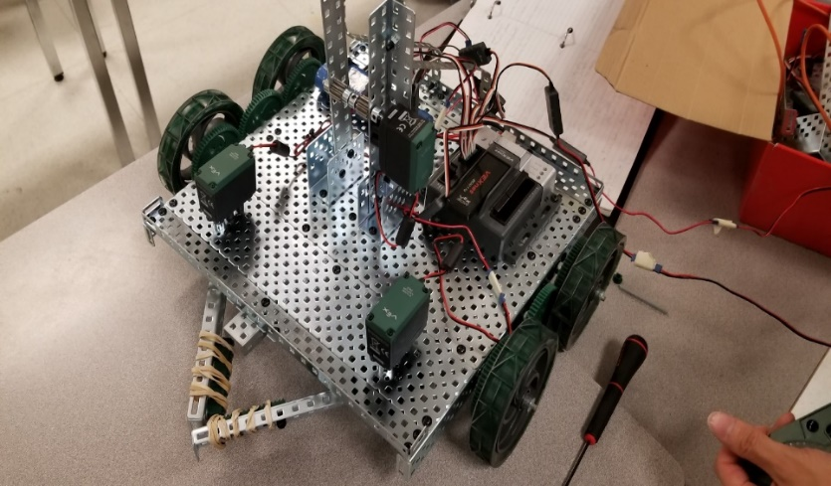Also due to the wider base it would increase the stability of the robot preventing unnecessary wobble and allowing all the components of the robot to fit on one floor rather than distributing it amongst multiple floors.
7. Once we recreated the chassis we tested to see if it was sturdier and could collect wooden blocks underneath and move efficiently.
8. 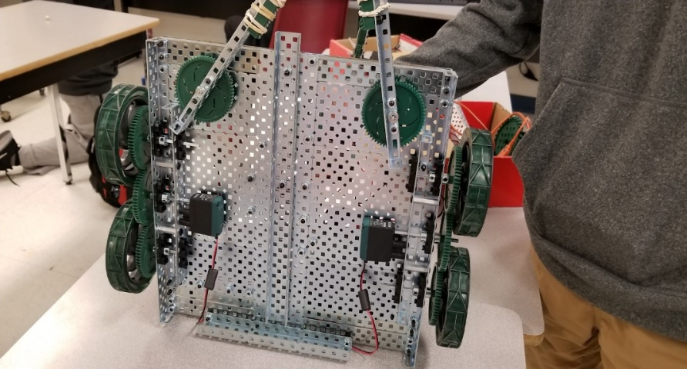After 3 successful drive tests I found that this chassis would satisfy the challenge goal and be the best structure to build the other parts off of.
9. After creating the optimal chassis for this assignment, I began to work on creating an intake system in which I would be able to efficiently collect the wooden blocks and place them in one shot.
10. As such myself and my partner devised that we could add some metal parts to align and hold the wooden blocks when they pass underneath the VEX unit.
11. 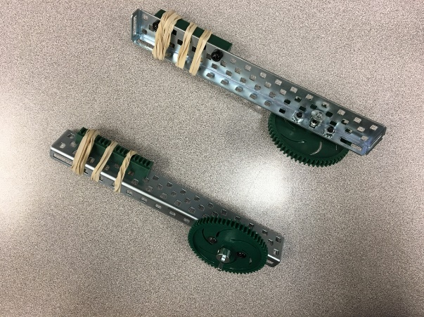We decided that we would add a barrier at the back of the metal frame to prevent the blocks from passing all the way through as well as a metal rail to align the wooden blocks as they pass through such that when we release them from underneath the robot the wooden blocks would come out in one straight line.
12. But then in order to make correction in the spacing between the blocks or any minor adjustments I decided to add pincers that way it would be easy to grab and move individual blocks.
13. 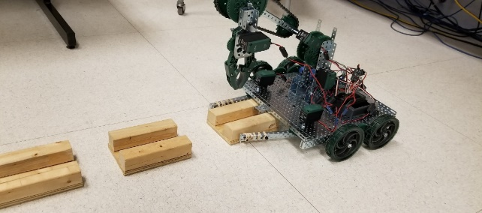While we tested this idea, we encountered a problem where the pincers were unable to grip the wooden blocks, so to solve that we decided to cover the claws with rubber bands to add extra grip to the pincer which allowed them to become a lot more effective and grab the wooden blocks easily.
14. 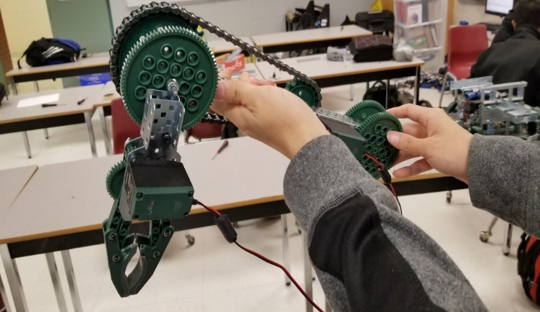We created a claw to allow the machine to pick up and move the pipes from the pipe rack to the wooden pipe cradle.
15. We also created an additional separate arm responsible for positioning the claw that way we are able to move the pipe a lot more effectively and accurately place the pipe into the wooden cradle
16. 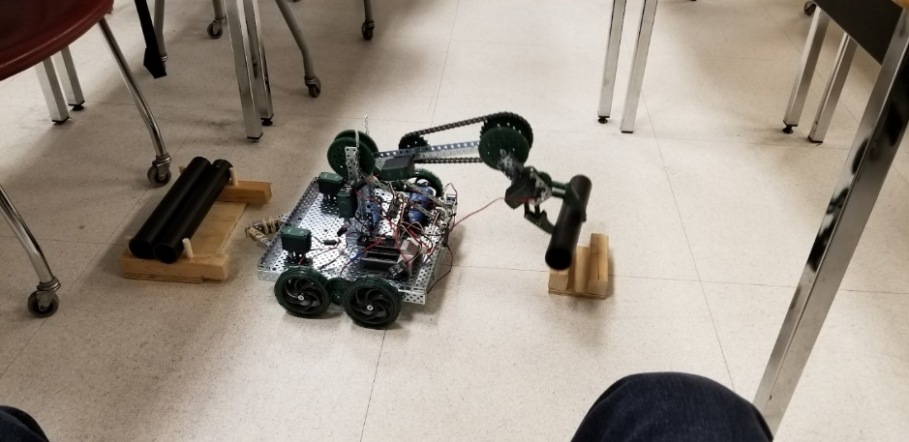After testing the arm we found that we were able to easily move the pipe from the pipe rack to the cradle without moving the entire unit but rather by rotating the arm 180o but after some testing I found that it lead to inaccuracy as the arm would constantly drop down due to its weight so to prevent unnecessary complications I stuck to just picking up the pipe turning the machine and placing the pipe.
17. When the midterm competition came around my robot was able to complete the challenge but with some minor difficulties with pipe placement because turning the robot took too much time and was inaccurate.
18. So, to resolve that problem I decided to reuse the initial idea of making the claw arm pick up a pipe and rotate all the way back to place it.
19. But in order to make this idea work and become more accurate I decided to create a pipe slide to allow the pipe to be placed smoothly into the wooden block.
20. 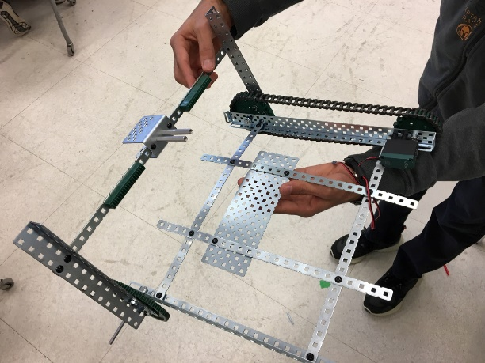But when tested there was a risk that the pipe could fall too fast and fall off the wooden block during placement.
21. To prevent that from happening my partner thought that we should add a motorized stopper so we can put it down when we need to, creating a pipe slide with a stopper.
22. 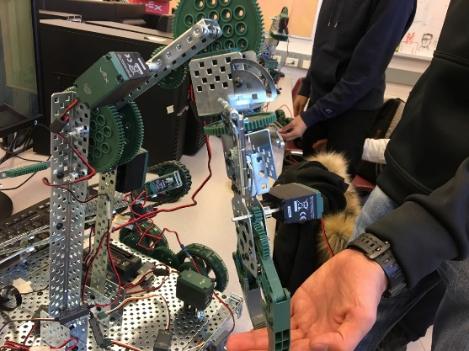When we went to test this pipe slide with the entire robot, we found that our current arm was too long and did not work well with the pipe slide so to fix it we replaced the main arm with a smaller metal C channel
23. 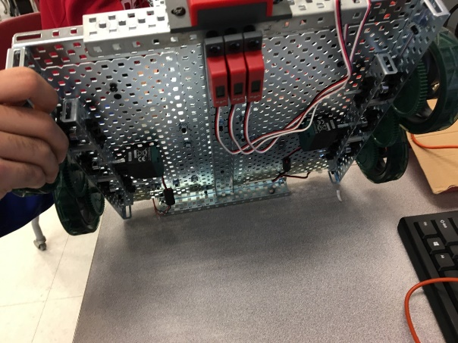Now we needed to create a system that would allow the robot to move autonomously. So, to aid the robot’s movement and make it as accurate as possible we decided to attach a line following system to the bottom of the robot that causes the robot to follow a black line on the floor.
24. 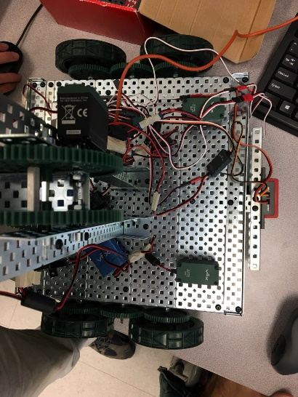When we tested it, it worked well but the problem we faced was that the robot would not stop and if it would there would not be enough room for the robot arm to move.
25. To fix this we added an ultrasonic sensor on the front of the robot that way after a certain distance the robot would stop and there would be enough room for the robot to place and pick up the standing pipes in the autonomous field
26. When we tested this new line following and stopping system it seemed to work but we had trouble going back in the other direction.
27. 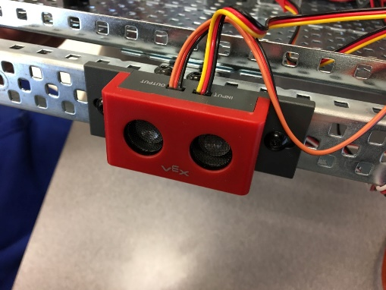So, to increase the efficiency of the pipe delivering we decided to add another ultrasonic sensor to the back of the robot to allow the pipe loading to occur in one smooth motion
28. The idea was that the robot would follow the line until a certain distance forward then pick up a pipe and follow the line backward then rotate the arm 180o and drop the pipe
29. When executing the idea, it worked initially but the robot had troubles following the line backwards, so I decided to scratch that idea
30. So now, the ultrasonic sensor on the back is made to help the robot understand its surroundings better
31. That way we are able to turn the robot around a lot smoother

**Evaluate:**

Overall Performance:

* Planning
  + I believe that I was very efficient in terms of planning in terms of robot creation
  + I was able to complete every task to a high level
  + But the only area I feel I should improve is looking for new ways to test a robot’s abilities rather than waiting for others to test their robot a certain way
* Designing
  + I believe my designing was very good because the block collecting method always guaranteed 3 blocks becoming perfectly aligned
  + In terms of the pipe setting I believe that was mostly due to lack of materials as the slide idea might have been a lot better if we were provided with omni wheels
  + Other than that, the ultrasonic sensors and pincers were also a huge success during the course of this product
* Problem Solving
  + Was able to create a game plan to allow for maximum efficiency and whenever a dilemma came up was able to quickly find a solution
  + This also led to the upbringing of new innovations and improvements
* Cooperation
  + Was able to successfully merge ideas with partner
  + Allowing for balanced work load and brainstorming the product is an accurate representation of the teamwork

**Overview of Solution:**

In the future I would like to create a system where the VEX unit would be allowed to strafe that way by strafing our vex unit is able to easily and accurately place the pipe on the wooden cradle and prevent any potential displacements during the pipe placement phase. Another addition to the VEX unit I would like to implement would be improving the pipe slide design. This slide would mean that I would no longer need to turn the entire robot around but rather pick up the pipe and drop it down the slide, and since the robot would be able to strafe that would mean that it would take even less time to place the pipes and become more accurate. But to allow the slide idea to be implemented further the arm motor needs to be stronger such that it is able to life the pipe all the way over the robot. I believe through these implementations it would reduce the amount of skill the driver needs to control the machine and more reliant on doing basic jobs such as picking up a pipe and releasing it. As such the pressure component of manually placing every part of the pipeline is relieved and the user would only be required to complete simple tasks and not worry about measurements and other complications. Also, I think that I would need to prepare and run multiple tests in terms of memorizing controls that way I would not was any time on trying to see what button controls a certain component during the competition. As a result of these three solutions, the unit would be able to complete the challenge quicker and more effectively possibly increasing our points from 7 to 45.

As mentioned previously through the SPICE formula:

* Size: The robot would need to become highly compatible with the field and its surroundings as such it needed to become as compact as possible but with the use of some extra equipment the base needed to become expanded leading to a moderate size robot
* Materials: The robot would be fully composed of metal components as it would allow for maximum stability and durability. These parts would already be provided to us for the competition robot build phase
* Finished Product: Tape was used to organize the clutter of wires and neatly organize them as well as zip ties to hold down the battery and support beams to prevent certain components from being crooked

Materials:

|  |  |  |
| --- | --- | --- |
| **Part Number** | **Part Name/Amount** | **Picture** |
| 1 | 84 Tooth Gear (x3) –  Used to attach components to as well as connect motor systems to static parts | Image result for 84 tooth gear VEX |
| 2 | 4-inch Shaft (x2) –  Used as an axle and attached to gears to allow components to rotate | Image result for 4 inch shaft VEX |
| 3 | 3-inch Shaft (x2) –  Used as an axle and attached to gears to allow components to rotate | Image result for 4 inch shaft VEX |
| 4 | 36 Tooth Gear (x1) –  components to as well as connect motor systems to static parts | Image result for VEX 32 tooth gear |
| 5 | Rack Gearbox Bracket (x4) –  Used as a stand to allow vertical metal pieces to be attached to horizontal metal pieces and vice versa | Image result for VEX rack gearbox |
| 6 | 60 Tooth Gear (x3)-  components to as well as connect motor systems to static parts | Image result for VEX 32 tooth gear |
| 7 | Pivot Gusset (x2) –  Used to limit the motion of claw | Image result for vex pivot gusset |
| 8 | Hinge (x2) –  Used to limit the motion of claw | Image result for vex hinge |
| 9 | Shaft Collar (x24) –  Used to hold axles in place | Image result for vex shaft collar |
| 10 | VEX Claw (x1) –  Used to pick up objects | Image result for vex claw |
| 11 | Chassis Bumper 25 Hole (x2) –  Metal frame used for structure | C:\Users\USER\AppData\Local\Microsoft\Windows\INetCache\Content.MSO\2010D41C.tmp |
| 12 | Chassis Rail 25 Hole (x6) –  Metal frame used for structure | Image result for vex chassis rail 25 hole |
| 13 | Chassis Rail 16 Hole (x2) –  Metal frame used for structure | Image result for vex chassis rail 25 hole |
| 14 | Plate 5x25 Hole (x4) –  Metal frame used for structure | Image result for vex plate 25 hole |
| 15 | Plate 5 x 15 (x1) –  Metal frame used for structure | Image result for vex plate 25 hole |
| 16 | C-Channel 1x2x1x15 (x5) –  Metal frame used for structure | Image result for vex c channel 15 hole |
| 17 | C-Channel 1x2x1x25 (x1) –  Metal frame used for structure | Image result for vex c channel 25 hole |
| 18 | Bar 1x25 (x7) –  Metal frame used for structure | Image result for vex bar 25 hole |
| 19 | 4-inch wheel (x4) –  Wheels used for robot movement | Image result for vex 4 inch wheel hole |
| 20 | Line Tracker (x3) –  Sensors used to allow robot to detect lines and navigate | Image result for vex line tracker |
| 21 | Ultrasonic Sensor (x2) –  Sensor used to allow robot to detect distances and navigate | Image result for vex ultrasonic sensor |
| 22 | VEX 393 motors (x6) –  Used to move robot components | Image result for vex 393 motor |
| 23 | VEX 269 motors (x2) –  Used to move robot components | Image result for vex 269 motor |
| 24 | VEX Rechargeable Battery (x1) –  Used to supply power to robot | Related image |
| 24 | VEX motor controllers (x8) –  Used to allow motors to be coded | Image result for vex motor controller |
| 25 | VEX Cortex (x1) –  Main control center where the interaction between code and component occurs (command center) | C:\Users\USER\AppData\Local\Microsoft\Windows\INetCache\Content.MSO\3D2B44BA.tmp |
| 26 | VEX Controller (x1) –  Used for Human Interface to send specific instructions to robot | Image result for vex controller |

**CAD Drawings/Sketches/Codes:**

**CAD Drawings:**

Basic Chassis – Arm Assembly –

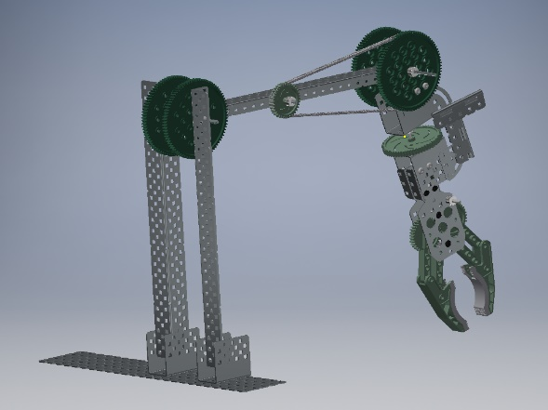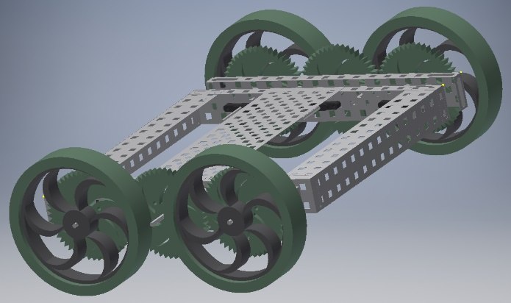

Complete Robot Assembly –

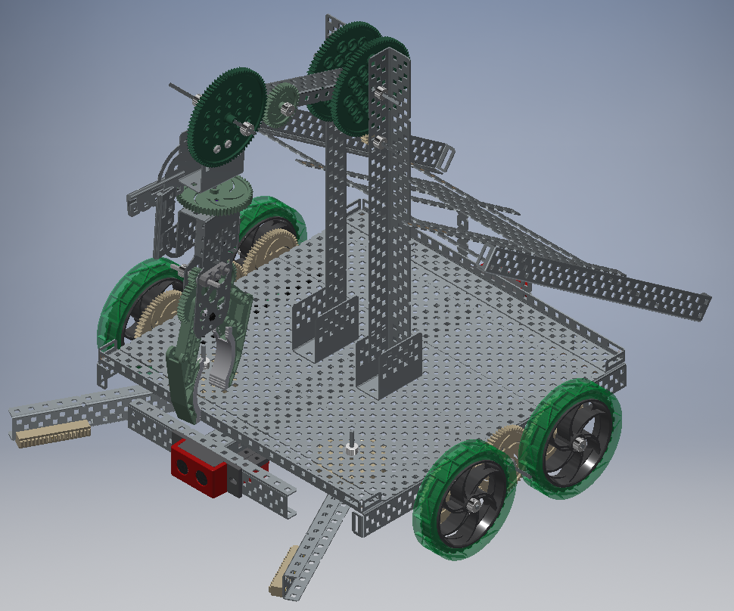

**Sketches:**

Base – Battery Base –

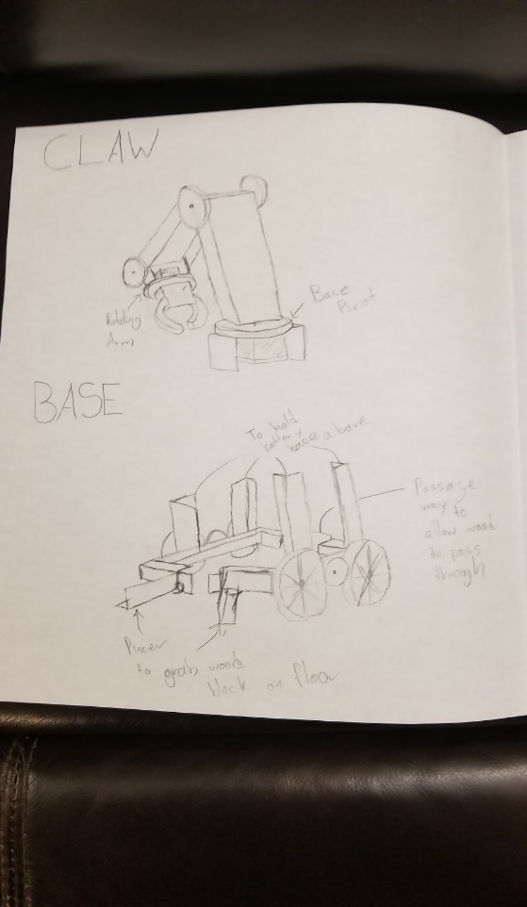 

Claw – Whole Concept –

 

**Coding:**

Manual Code:

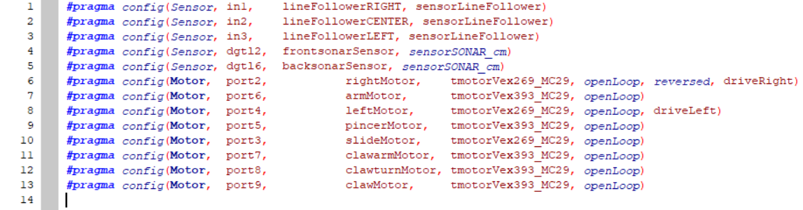

Variables being assigned to corresponding motor/sensor ports

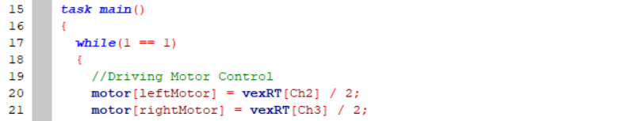

A while loop is created such that the loop will always run

The y-axis on the left and right joysticks on the VEX controller are being assigned to control the left and right motors for movement

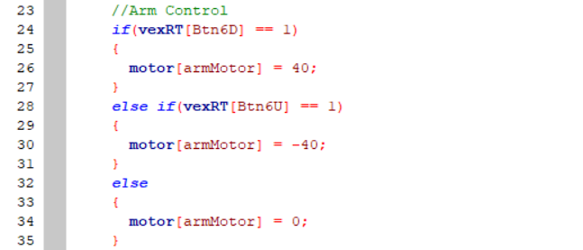

The trigger buttons (6U/6D) on the VEX controller are being assigned to raise and drop the main arm of the robot otherwise if no button is pressed the arm motor does not move

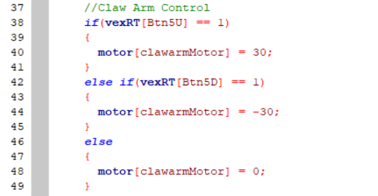

The trigger buttons (5U/5D) on the VEX controller are being assigned to raise and drop the arm (which the claw is attached to) of the robot otherwise if no button is pressed the arm motor does not move

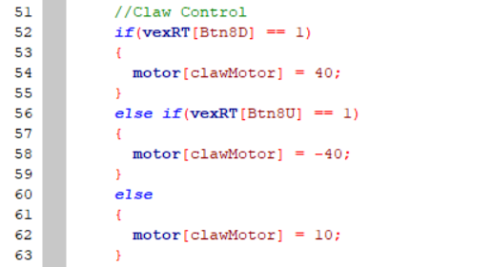

The right pad buttons (8D/8U) on the VEX controller are being assigned to open and close the robot’s claw otherwise if no button is pressed then the claw constantly closes by a value of 10

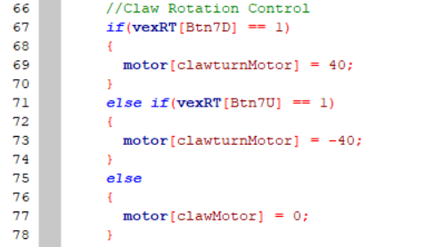

The left pad buttons (7D/7U) on the VEX controller are being assigned to rotate the claw clockwise and counter-clockwise and if no button is pressed then the claw does not rotate

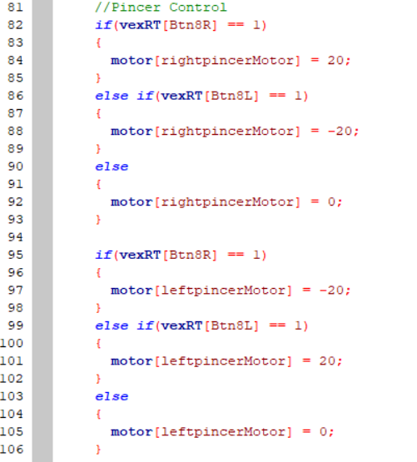

The right pad buttons (8R/8L) on the VEX controller are being assigned to open and close the robot’s pincers otherwise if no button is pressed then the pincers do not move

The pincers are coded such that what if the right pincer was to rotate clockwise the left pincer would rotate counter-clockwise and vice versa

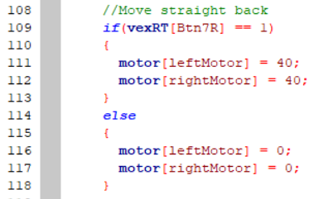

The left pad button (7R) on the VEX controller is being assigned to move the robot backwards and if no button is pressed then the claw does not rotate

Autonomous Code:

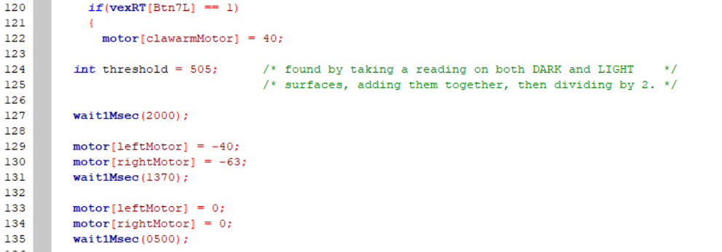

When the button 7L is pressed on the VEX controller the following subprogram is executed, the claw arm is made to constantly stay raised from the beginning

There is an integer assigned called “threshold” to determine line following

Then the robot proceeds to move forward at a slant then stop

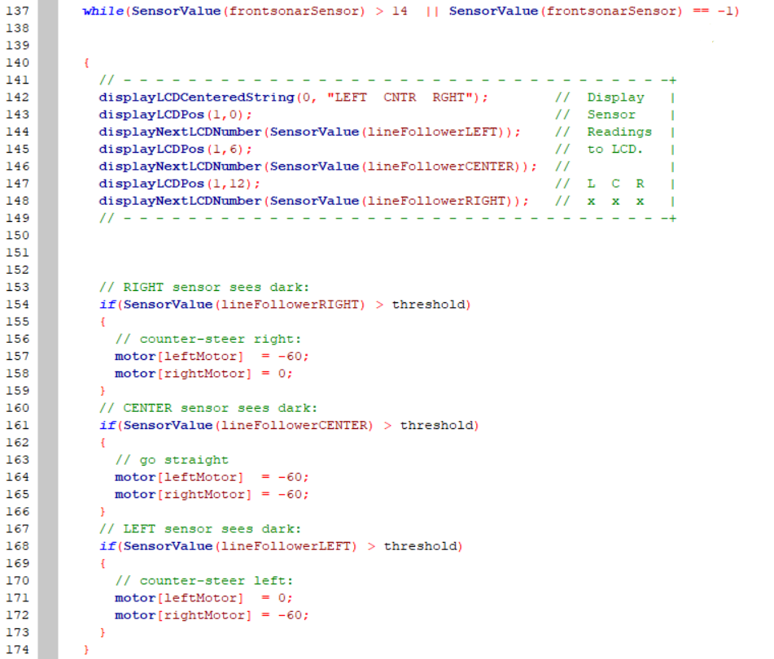

A while loop begins as long as the ultrasonic sensor in the front is further than 14cm from an object

If the right sensor sees a black line the robot steers right, if left it steers left, and if in the middle the robot goes straight

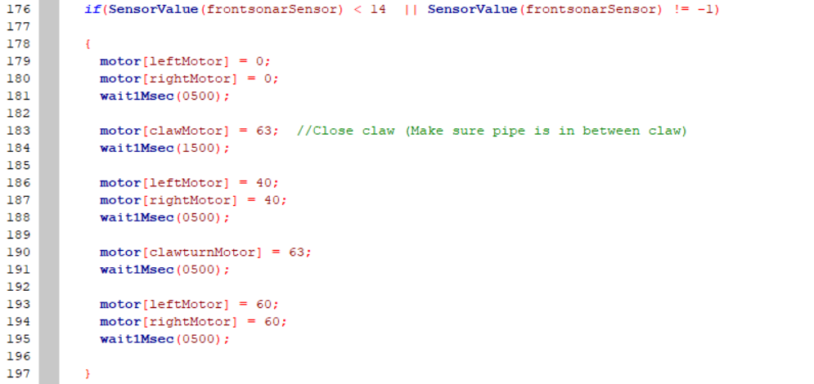

If the front sensor is closer than 14cm to an object the motors stop, the claw picks up the pipe by closing, then the robot moves back and rotates the claw and continue to proceed backwards

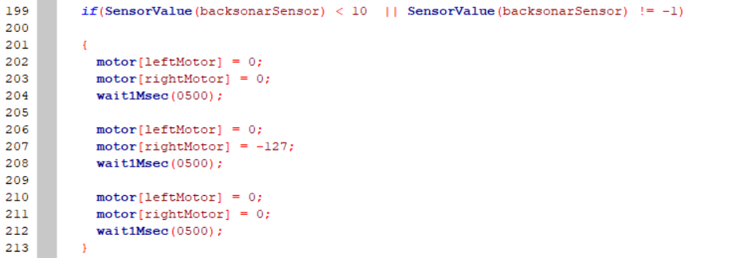

Once the rear sensor is closer than 10cm to an object then the robot stops moving and then makes a round left turn and stops



A while loop begins as long as the ultrasonic sensor in the front is further than 14cm from an object

If the right sensor sees a black line the robot steers right, if left it steers left, and if in the middle the robot goes straight

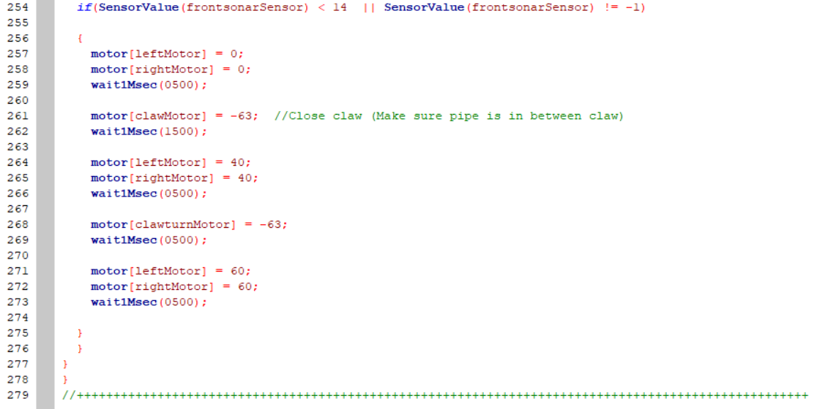

If the front sensor is closer than 14cm to an object the motors stop, the claw drops off the pipe by opening, then the robot moves back and rotates the claw and continues to proceed backwards. The program then ends.

**Daily Journal:**

|  |  |
| --- | --- |
| Date | Description |
| December 3 | Returned from vacation, began working on robot arm on inventor |
| December 4 | Continued working on robot arm in inventor   * Completed base stand * Began working on base arm |
| December 5 | Continued working on arm inventor   * Completed base arm * Working on base claw and claw |
| December 6 | Continued arm in inventor   * Completed claw and claw arm * Began adding small additions   + Shaft collars   + Screws |
| December 7 | Finished arm in inventor   * Added chain * Submitted work |
| December 10 | Began brainstorming on how to edit initial robot design   * How to apply edits required mentioned in previous report |
| December 11 | Continued researching and experimenting with designs   * Attempted to create a metal slide for pipes * Discontinued because omni wheels seemed like a better alternative |
| December 12 | Attempted to attach omni wheels but rendered more useless than useful   * Required more space and became an obstacle to some mechanisms |
| December 13 | Resumed experimenting with design   * Resumed creating a metal slide * Found that it was too unstable so began looking for ways to improve |
| December 14 | Was unable to find solution to slide design problem so put it on pause  Began learning about VEX sensors |
| December 17 | Continued looking at different VEX sensors   * Bumper switches * Line sensors |
| December 18 | Found a solution to slide problem   * Decided to create a trey-like slide shape   + Could be built more sturdy   + Easy to attach on back of VEX unit |
| December 19 | Continued working on trey-slide   * Measured to make sure pipe would be ale to fit and pass through * Reinforced structure with metal plates |
| December 20 | Finished working on trey-slide   * Added railings to prevent pipe from drifting off the slide * Attached the metal trey-slide to supporting beams of VEX unit |
| December 21 | Attended Talent Show |
| January 7 | Tested pipe slide   * Found that the pipe could drop too fast * Concluded to create a pipe stopper |
| January 8 | Began constructing pipe stopper   * Created gear and chain system to allow user to raise and lower stopper |
| January 9 | Completed pipe stopper   * Built metal bar to stop pipe and attached to a motor * Attached mechanism to trey slide |
| January 10 | Began attaching line sensors to VEX unit |
| January 11 | Tried to adjust line sensors such that robot movement could function solely on-line sensors |
| January 14 | Found that attaching an additional ultrasonic sensor would allow robot movement to become a lot smoother |
| January 15 | Created autonomous code for autonomous phase of summative |
| January 16 | Testing   * Decided to add an additional ultrasonic sensor to improve maneuverability |
| January 17 | Testing   * Changes a couple values in code |
| January 18 | Needed to rebuild a component of robot due to being dismantled by an outsider |

**Self-Evaluation:**

Autonomous;

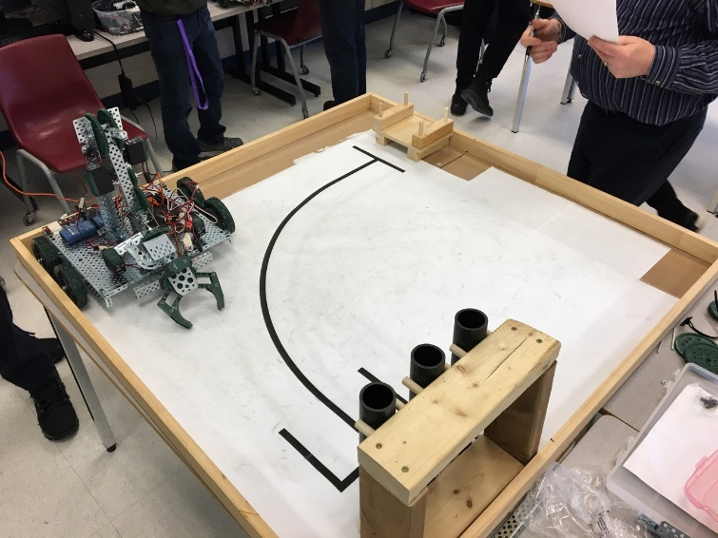During the autonomous I was able to create a robot that was capable of transporting a pipe quickly and efficiently. Majority of the success was due to the dual ultrasonic sensor system which drastically increased the chances and the accuracy of the pipe delivery system. The only area I believe we fell short in was time/space management. This is because there were too many competitors testing their robots using the competition field which lead to waiting lines and that in itself would reduce my available work time by 50%. So, I believe that if I we were provided more “testing fields” or was able to utilize my surroundings a bit better I would have been able to deliver all 3 pipes to the station in one code.

Manual;

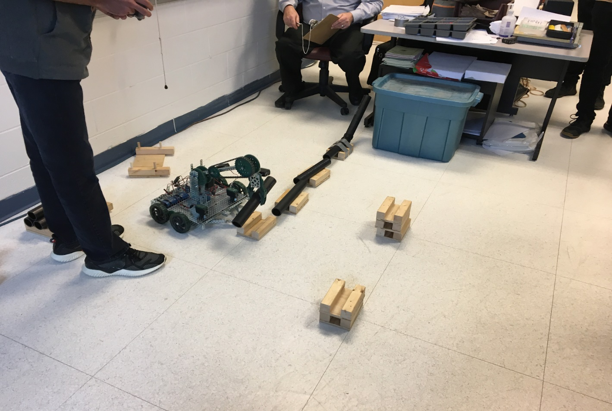During the competition first trial I began by driving up to the first stack of wooden cradles and attempted to knock them down in a straight line. While knocking them down I had miscalculated and one of the blocks did not fall down completely so I had to readjust and knock it down again. After all the blocks dropped the VEX unit collected them using the pincer intake mechanism and then I proceeded to align the blocks in front of the main station. But due to some problem with the motors my robot was moving in a very clunky and slow manner. After successfully placing and separating the blocks I placed the pipes but struggled in aligning them. As such the balls were only able to pass through one of the pipes and even then, only one ball bearing passed through. Not to mention pipe slide system did not work due to there being too much load on the claw arms which meant they were not strong enough to lift pipe up and over robot and into the pipe slide. To improve this, I believe that we could either replace the arm motor with a stronger motor. Also, I believe that there must’ve been some faulty with the coding as the motors were not very responsive to the controller commands. As such I the efficiency of the pipeline creation was heavily reduced.

Overall;

Overall, I found this experience to be very fun as well as difficult because I enjoyed the physical building component, but much despised the inventor and the coding component simply because it would be very frustrating as the inventor tutorial videos were captivating and did not teach enough. Meanwhile while coding the robot what would normally make logical sense didn’t work with the robot due to external factors such robot weight and motor power. But otherwise seeing my ideas becoming put into practical use and seeing them becoming heavily adapted by other groups made me feel very good as it shows how good the idea was. I decided to look into ultrasonic sensors and bumper switches as they were not part of the curriculum and they proved to become a key factor in the autonomous phase of the final summative. If I had more time, I would definitely spend more time practicing driving the robot and also replace the current wheel set with omni wheels otherwise I truly believe our robot is the most ideal for this competition.

**References:**

“Appendix 1: Programming & Sensors.” *1.3: What Is the Engineering Design Process? |*

*VEX EDR Curriculum*, curriculum.vexrobotics.com/appendices/appendix-1.html.

“Appendix 9: Autodesk VEX Robotics Parts Library and Basic Commands

Overview.” *1.3: What Is the Engineering Design Process? | VEX EDR Curriculum*, curriculum.vexrobotics.com/appendices/appendix-9.html.

Z, Mr. *YouTube*, YouTube, 8 Feb. 2017, [www.youtube.com/watch?v=X4WiAz3Y43A](http://www.youtube.com/watch?v=X4WiAz3Y43A).

Skills Robotics PDF www.skillsontario.com/index.php?p=download&file=739